ONEWAY PREC BY RES
/STATISTICS DESCRIPTIVES HOMOGENEITY WELCH
/PLOT MEANS
/MISSING ANALYSIS.

Oneway

Notes
Output Created |  | 06-May-2019 00:05:52
Comments
Input | Active Dataset | DataSet0
Input | Filter | <none>
Input | Weight | <none>
Input | Split File | <none>
Input | N of Rows in Working Data File | 30
Missing Value Handling | Definition of Missing | User-defined missing values are treated as missing.
Missing Value Handling | Cases Used | Statistics for each analysis are based on cases with no missing data for any variable in the analysis.
Syntax |  | ONEWAY PREC BY RES  /STATISTICS DESCRIPTIVES HOMOGENEITY WELCH  /PLOT MEANS  /MISSING ANALYSIS.
Resources | Processor Time | 00 00:00:00.156
Resources | Elapsed Time | 00 00:00:00.174

[DataSet0]

Descriptives
 | N | Mean | Std. Deviation | Std. Error | 95% Confidence Interval for Mean
 |  |  |  |  | Lower Bound | Upper Bound
1360x768 | 7 | 82.8571 | 47.33367 | 17.89045 | 39.0808 | 126.6335
1920x1080 | 15 | 37.3333 | 25.69510 | 6.63445 | 23.1039 | 51.5628
800x600 | 8 | 24.3750 | 14.50062 | 5.12674 | 12.2522 | 36.4978
Total | 30 | 44.5000 | 36.42067 | 6.64947 | 30.9003 | 58.0997

Descriptives
 | Minimum | Maximum
1360x768 | 5.00 | 130.00
1920x1080 | .00 | 80.00
800x600 | 10.00 | 50.00
Total | .00 | 130.00

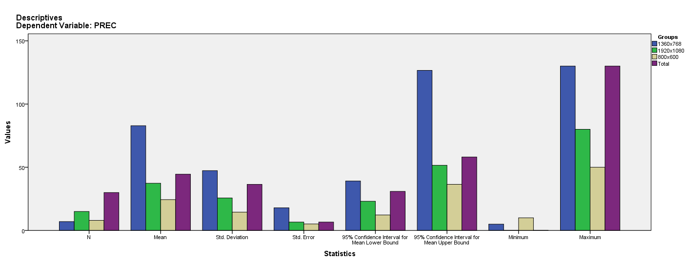

Test of Homogeneity of Variances
PREC
Levene Statistic | df1 | df2 | Sig.
8.455 | 2 | 27 | .001

ANOVA
PREC
 | Sum of Squares | df | Mean Square | F | Sig.
Between Groups | 14309.435 | 2 | 7154.717 | 7.996 | .002
Within Groups | 24158.065 | 27 | 894.743
Total | 38467.500 | 29

Robust Tests of Equality of Means
PREC
 | Statisticª | df1 | df2 | Sig.
Welch | 5.204 | 2 | 13.085 | .022
a. Asymptotically F distributed.

Means Plots

